BACHELOR OF SCIENCE IN DATA SCIENCE & BACHELOR OF BUSINESS INFORMATION TECHNOLOGY
LECTURE NOTES
ICS 2307: MODELING AND SIMULATION
MODELING
Modeling is the process of producing a model; a model is a representation of the construction and working of some system of interest. A model is similar to but simpler than the system it represents. One purpose of a model is to enable the analyst to predict the effect of changes to the system. On the one hand, a model should be a close approximation to the real system and incorporate most of its salient features. On the other hand, it should not be so complex that it is impossible to understand and experiment with it. A good model is a judicious tradeoff between realism and simplicity. Simulation practitioners recommend increasing the complexity of a model iteratively. An important issue in modeling is model validity.
Model validation techniques include simulating the model under known input conditions and comparing model output with system output.
Generally, a model intended for a simulation study is a mathematical model developed with the help of
simulation software. Mathematical model classifications include deterministic (input and output variables are fixed values) or stochastic (at least one of the input or output variables is probabilistic); static (time is not taken into account) or dynamic (time-varying interactions among variables are taken into account). Typically, simulation models are stochastic and dynamic.
SIMULATION?
Simulation is the most important technique used in analyzing a number of complex systems where the methods discussed in previous chapters are not adequate. There are many real world problems which cannot be represented by a mathematical model due to stochastic nature of the problem, the complexity
in problem formulation and many values of the variables are not known in advance and there is no easy way to find these values.
Simulation has become an important tool for tackling the complicated problem of managerial decision-making. Simulation determines the effect of a number of alternate policies without disturbing the real system. Recent advances in simulation methodologies, technical development and software availability have made simulation as one of the most widely and popularly accepted tool in Operation Research. Simulation is a quantitative technique that utilizes a computerized mathematical model in order to represent actual decision-making under conditions of uncertainty for evaluating alternative courses of action based upon facts and assumptions. Stainslaw Ulam made first important application of simulation for determining the complicated behaviour of neutrons in a nuclear shielding problem, being too complicated for mathematical analysis. After the remarkable success of this technique on neutron problem, it has become more popular and has many applications in business and industry. The development of digital computers has further increased the rapid progress in the simulation technique.
Designers and analysts have long used the techniques of simulation by physical sciences. Simulation is the representative model of real situation. Fore example, in a city, a children's park with various signals and crossing is a simulated model of city traffic. A planetarium is a simulated model of the solar system. In laboratories we perform a number of experiments on simulated model to predict the behaviors of the real system under true environment. For training a pilot, flight simulators are used. The simulator under the control of computers gives the same readings as the pilot gets in real flight. The trainee can intervene when there is signal, like engine failure etc. Simulation is the process of generating values using random number without really conducting experiment. Whenever the experiments are costly or infeasible or time-consuming simulation is use d to generate the required data.
A simulation of a system is the operation of a model of the system. The model can be reconfigured and
experimented with; usually, this is impossible, too expensive or impractical to do in the system it represents. The operation of the model can be studied, and hence, properties concerning the behavior of the actual system or its subsystem can be inferred. In its broadest sense, simulation is a tool to evaluate the performance of a system, existing or proposed, under different configurations of interest and over long periods of real time. Simulation is used before an existing system is altered or a new system built, to reduce the chances of failure to meet specifications, to eliminate unforeseen bottlenecks, to prevent under or over-utilization of resources, and to optimize system performance. For instance, simulation can be used to answer questions like: What is the best design for a new telecommunications network? What are the associated resource requirements? How will a telecommunication network perform when the traffic load increases by 50%? How will a new routing algorithm affect its performance? Which network protocol optimizes network performance? What will be the impact of a link failure? The subject of this tutorial is discrete event simulation in which the central assumption is that the system changes instantaneously in response to certain discrete events. For instance, in a queue – a single server queuing process in which time between arrivals and service time are exponential - an arrival causes the system to change nstantaneously. On the other hand, continuous simulators, like flight simulators and weather simulators, attempt to quantify the changes in a system continuously over time in response to controls. Discrete event simulation is less detailed (coarser in its smallest time unit) than continuous simulation but it is much simpler to implement, and hence, is used in a wide variety of situations.
.
There are two types of simulation, they are:
1. Analog Simulation: Simulating the reality in physical form (e.g.: Children's park, planetarium, etc.) is known as analog simulation.
2. Computer Simulation: For problems of complex managerial decision-making, the analogue simulation may not be applicable. In such situation, the complex system is formulated into a mathematical model for which a computer programme is developed. Using high-speed computers then solves the problem. Such type of simulation is known as computer simulation or system simulation.
CLASSIFICATION OF SIMULATION MODELS
Simulation models are classified as:
(a) Simulation of Deterministic models:
In the case of these models, the input and output variables are not permitted to be random variables and models are described by exact functional relationship.
(b) Simulation of Probabilistic models:
In such cases method of random sampling is used. The techniques used for solving these models are termed as Monte-Carlo technique.
(c) Simulation of Static Models:
These models do not take variable time into consideration.
(d) Simulation of Dynamic Models:
These models deal with time varying interaction.
WHEN SIMULATION IS THE APPROPRIATE TOOL
The availability of special-purpose simulation languages, of massive computing capabilities at a decreasing cost per operation, and of advances in simulation methodologies have made simulation one of the most widely used and accepted tools in operations research and systems analysis. Simulation can be used for the following purposes:
1. Simulation enables the study of, and experimentation with, the internal interactions of a complex system or of a subsystem within a complex system.
2. Informational, organizational, and environmental changes can be simulated, and the effect of these alterations on the model's behavior can be observed.
3. The knowledge gained during the designing of a simulation model could be of great value toward suggesting improvement in the system under investigation.
4, Changing simulation inputs and observing the resulting outputs can produce valuable insight into which variables are the most important and into how variables interact.
5. Simulation can be used as a pedagogical device to reinforce analytic solution methodologies.
6. Simulation can be used to experiment with new designs or policies before implementation, so as to prepare for what might happen.
7. Simulation can be used to verify analytic solutions.
8. Simulating different capabilities for a machine can help determine the requirements on it.
9. Simulation models designed for training make learning possible without the cost and disruption ofon-the-job instruction.
10. Animation shows a system in simulated operation so that the plan can be visualized.
11. The modem system (factory, wafer fabrication plant, service organization, etc.) is so complex that its internal interactions can be treated only through simulation.
WHEN SIMULATION IS NOT APPROPRIATE
The first rule indicates that simulation should not be used when the problem can be solved by common sense. An example is given of an automobile tag facility serving customers who arrive
randomly at an average rate of 100/hour and are served at a mean rate of 12/hour. To determine the minimum number of servers needed, simulation is not necessary. Just compute 100/12 = 8.33 indicating that nine or more servers are needed.
The second rule says that simulation should not be used if the problem can be solved analytically. For example, under certain conditions, the average waiting time in the example above can be found from curves.
The next rule says that simulation should not be used if it is easier to perform direct experiments. An example of a fast-food drive-in restaurant is given where it was less expensive to stage a person taking orders using a hand-held terminal and voice communication to determine the effect of adding another order station on customer waiting time.
The fourth rule says not to use simulation if the costs exceed the savings.
ADVANTAGES AND DISADVANTAGES OF SIMULATION
Simulation is intuitively appealing to a client because it mimics what happens in a real system or what is perceived for a system that is in the design stage. The output data from a simulation should directly correspond to the outputs that could be recorded from the real system. Additionally, it is possible to develop a simulation model of a system without dubious assumptions (such as the same statistical distribution for every random variable) of mathematically solvable models. For these and other reasons, simulation is frequently the technique of choice in problem solving.
In contrast to optimization models, simulation models are "run" rather than solved. Given a particular set of input and model characteristics, the model is run and the simulated behavior is observed. This process of changing inputs and model characteristics results in a set of scenarios that are evaluated. A good solution, either in the analysis of an existing system or in the design of a new system, is then recommended for implementation.
Some advantages are these:
1. New policies, operating procedures, decision rules, information flows, organizational procedures, and so on can be explored without disrupting ongoing operations of the real system.
2. New hardware .designs, physical layouts, transportation systems, and so on can be tested without committing resources for their acquisition.
3. Hypotheses about how or why certain phenomena occur can be tested for feasibility.
4. · Time can be compressed or expanded to allow for a speed-up or slow-down of the phenomena under investigation.
5. Insight can be obtained about the interaction of variables.
6. Insight can be obtained about the importance of variables to the performance of the system.
7. Bottleneck analysis can be performed to discover where work in process, information, materials, and so on are being delayed excessively.
8. A simulation study can help in understanding how the system operates rather than how individuals think the system operates. .
9"What if' questions can be answered. This is particularly useful in the design of new systems.
Some disadvantages are these:
- Model building requires special training. It is an art that is learned over time and through experience. Furthermore, if two models are constructed by different competent individuals, they might have similarities, but it is highly unlikely that they will be the same
2. Simulation results can be difficult to interpret Most simulation outputs are essentially random variables (they are usually based on random inputs), so it can be hard to distinguish whether an observation is a result of system interrelationships. or of randonmess.
3. Simulation modeling and analysis can be time consuming and expensive. Skimping on resources for modeling and analysis could result in a simulation model or analysis that is not sufficient to the task.
4. Simulation is used in some cases when an analytical solution is possible, or even preferable
This might be particularly true in the simulation of some waiting lines where closed-form queueing models are available.
In defense of simulation, these four disadvantages, respectively, can be offset as follows:
1. Vendors of simulation software have been actively developing packages that contain models that need only input data for their operation. Such models have the generic tag "simulator" or "template."
2. Many simulation software vendors have developed output-analysis capabilities within their packages for performing very thorough analysis.
3. Simulation can be performed faster today than yesterday and will be even faster tomorrow, because of advances in hardware that permit rapid running of scenarios and because of advances in many simulation packages. For example, some simulation software contains constructs for modeling material handling that uses such transporters as fork-lift trucks, conveyors, and automated guided vehicles.
4. Closed-form models are not able to analyze most of the complex systems that are encountered in practice. In many years of consulting practice by two of the authors, not one problem was encountered that could have been solved by a closed-form solution
AREAS OF APPLICATION
Manufacturing Applications
Dynamic modeling of continuous manufacturing systems, using analogies to electrical systems
Benchmarking of a stochastic production planning model in a simulation test bed
Paint line color change reduction in automobile assembly
Modeling for quality and productivity in steel cord manufacturing
Shared resource capacity analysis in biotech manufacturing
Neutral information model for simulating machine shop operations
Construction Engineering and Project Management
Impact of multitasking and merge bias on procurement of complex equipment
Application of lean concepts and simulation for drainage operations maintenance crews
Building a virtual shop model for steel fabrication
Simulation of the residential lumber supply chain
Military Applications .
Frequency-based design for terminating simulations: A peace-enforcement example
A multibased framework for supporting military-based interactive simulations in 3D environments
Specifying the behavior of computer-generated forces without programming
Research plan development for modeling and simulation of military operations in urban terrain
Logistics, Supply Chain, and Distribution Applications
Inventory analysis in a server-computer manufacturing environment
Comparison of bottleneck detection methods for AGV systems
Semiconductor supply-network simulation
Analysis of international departure passenger flows in an airport terminal
Application of discrete simulation techniques to liquid natural gas supply chains
Online simulation of pedestrian flow in public buildings
Transportation Modes and Traffic
Simulating aircraft-delay absorption
Runway schedule determination by simulation optimization
Simulation of freeway merging and diverging behavior
Modeling ambulance service of the Austrian Red Cross .
Simulation modeling in support of emergency firefighting in Norfolk
Modeling ship arrivals in ports
Optimization of a barge transportation system for petroleum delivery
Iterative optimization and simulation of barge traffic on an inland waterway
Business Process Simulation
Agent-based modeling and simulation of store performance for personalized pricing
Visualization of probabilistic business models
Modeling and simulation of a telephone call center
Simulation's role in baggage screening at airports
Human-fatigue risk simulations in continuous operations
Optimization of a telecommunications billing system
Segmenting the customer base for maximum returns
Health Care
Modeling front office and patient care in ambulatory health care practices
Evaluation of hospital operations between the emergency department and a medical telemetry unit
Reducing the length of stay in an emergency department
Simulating six-sigma improvement ideas for a hospital emergency department
A simulation-integer-linear-programming-based tool for scheduling emergency room staff
1.7 DISCRETE AND CONTINUOUS SYSTEMS
Systems can be categorized as discrete or continuous. "Few systems in practice are wholly discrete or continuous, but since one type of change predominates for most systems, it will usually be possible to classify a system as being either discrete or continuous. A discrete system is one in which the state variable(s) change only at a discrete set of points in time. The bank is an example of a discrete system: The state variable, the number of customers in the bank, changes only when a customer arrives or when the service provided a customer is completed Figure 1.1 shows how the number of customers changes only at discrete points in time.
A continuous system is one in which the state variable(s) change continuously over time. An example is the head of water behind a dam. During and for some time after a rain storm, water flows into the lakebehind the dam. Water is drawn from the dam for flood control and to make electricity. Evaporation also decreases the water level. Figure 1.2 shows how the state variable head of water behind the dam changes for this continuous system.
1MODEL OF A SYSTEM
Sometimes it is of interest to study a system to understand the relationships between its components or to predict how the system will operate under a new policy. To study tbe system, it is sometimes possible to experiment with the system itself. However, this is not always possible. A new system might not yet exist; it could be in only hypothetical form or at the design stage. Even if the system exists, it might be impractical to experiment with it. For example, it might not be wise or possible to double the unemployment rate to discover the effect of employment on inflation. In the case of a bank, reducing the numbers of tellers to study the effect on the length of waiting lines might infuriate the customers so are ready that they move their accounts to a competitor. Consequently, studies of systems are often accomplished with a model of a system.
We had a consulting job for the simulation of a redesigned port in Western Australia. At $200 millions for a loading/unloading berth, it's not advisable to invest that amount only to find that the berth is inadequate for the task.
A model is defined as a representation of a system for the purpose of studying the system. For most studies, it is only necessary to consider those aspects of the system that affect the problem under investigation. These aspects are represented in a model of the system; the model, by definition, is a simplification of the system. On the other hand, the model should be sufficiently detailed to permit valid conclusions to be drawn about the real system. Different models of the same system could be required as the purpose of investigation changes.
Systems and System Environment
􀂄 A system is defined as a groups of objects thatare joined together in some regular interaction toward the accomplishment of some purpose.
􀂅 An automobile factory: Machines, components parts and workers operate jointly along assembly line
􀂄 A system is often affected by changes occurring outside the system: system environment.
􀂅 Factory : Arrival orders
􀂄 Effect of supply on demand : relationship between factory
output and arrival (activity of system)
􀂅 Banks : arrival of customers
Components of system
Entity - An object of interest in the system : Machines in factory
Attribute - The property of an entity : speed, capacity
Activity - A time period of specified length :welding, stamping
State - A collection of variables that describe the system in any time : status of machine (busy, idle, down,…)
Event - A instantaneous occurrence that might change the state of the system: breakdown
Endogenous - Activities and events occurring with the system
Exogenous - Activities and events occurring with the environment

Model Building
Model building is an art. Indeed, good model builders are equally engineers and artists. As a result, models built by different groups for the same purpose will usually look quite different. Such models will have many features in common, but there will also be substantial differences due to the different perception of the real world. The following is a minimal list of requirements for any good model:
- The model should model and show the operations of the system in question.
- The model should provide a solution to a real world problem.
- The model should be for the benefit of those who asked for the design of the model.
At the model building stage we can reiterate some of the common problems: Good models are expensive and time consuming. This applies both to the human factor, i.e., to the people involved, as well to computing power. Models are almost always imprecise since models are almost never a complete picture of the real world. Models may appear to be accurate where in fact they aren’t. The converse is also true, where models may be accurate where they don’t appear to be. Another common problem is that with the design of a (mathematical) model we will associate numbers to certain data. This may suggest a greater degree of validity to the model or its outcome than is actually justified.
Input Modelling
Once the model is designed data has to be collected and parameters have to be estimated. This is where all the statistical methods are applied: Input data has to be collected for the various input processes.
Possible input distributions have to be selected to represent those input processes. The choice is between theoretical distributions or empirical distributions. Goodness-to-fit hypothesis testing is used to determine whether collected input data matches a given theoretical distribution. If the model is used to predict effects of new procedures then there may not be any data to collect. In this case theoretical distributions have to be chosen to model various input processes. Parameters of the distributions have to be estimated using either point estimators or interval estimators. Let us state again the main use of the most important probability distributions:
Binomial distribution. This distribution models the number of successes in successive trials, where the trials are independent from each other and there is a common success probability
Poisson distribution. This distribution is used to model arrival processes in fixed time intervals where arrivals are independent. Thus this distribution can be used to model arrivals of customers at a counter, or arrivals of printer jobs at the printer queue.
Exponential distribution. The exponential distribution models time between independent events. A typical use of this distribution is the time between arrivals at a counter. If arrivals are modeled by the Poisson distribution then inter-arrivals are modeled by the exponential distribution.
Normal distribution. The normal distribution is the most common distribution. It often models errors or processing time due to its symmetric character.
Verification and Validation
Verification and validation are two important steps in design. Verification refers to whether a model behaves as intended. Validation refers to the agreement between a model and the real world. Verification and validation are also seen as answers to the questions ’are we building the model right?’ (verification) and ’are we building the right model?’ (validation). Thus validation relates the real world with the conceptual model, while verification relates the conceptual model with the operational model:
Validation aims to establish confidence into the model, i.e., confidence that the model is indeed a true picture of the real world. A model that is not validated is only of academic interest and of hardly any use in decision making or analysing a real-world situation. Since validation is part of the art no prescribed mechanism exists for it. However, basic guidelines are the following:
- Results (say outcomes of the model) must be reasonable. This is often established with test data where the correct outcome is known beforehand.
- Testing of assumptions.
- Testing of input-output transformations, i.e., does a certain variation of the input parameters result in reasonable changes of the output results.
Validation is usually achieved through common sense and logic, by taking advantage of knowledge and insight available, by empirical testing, by paying attention to details, by debugging of the program, by input-output analysis and comparison with real-life data, and by checking predictions. From this list it becomes clear that next to data and results we also validate concepts, methodology, and inferences. Calibration of the model may be seen as part of the validation process. Every model is only a partial representation of the real world. Calibration is the fine tuning of the validated model. It describes how accurate or inaccurate the model is. Calibration is the term used for the fine tuning of parameters of a system (like input distributions, parameters of the distributions, etc.). To be able to calibrate the major part of the modelvhas be be validated.
A test often used in validating models is the Turing test. Real reports are mixed with fake reports based on model predictions. If experienced people cannot tell apart the reports then this suggests that the model in question is an accurate picture of the real world. Verification is the formal process whereby it is checked that the implementation of the model is an accurate representation of the conceptual model. Typical verification techniques include the following:
- Code is checked by someone else;
- /use of flow charts or other visual aids in the design of the implementation;
- examination of output and comparison with real life;
- careful debugging;
- thorough documentation;
- examination of subsystem and subsystem testing.

LIMITATIONS OF SIMULATION TECHNIQUE
* Since simulation model mostly deals with uncertainties, the results of simulation are only reliable approximations involving statistical errors, optimum results cannot be produced by simulation.
* In many situations, it is not possible to identify all the variables, which affect the behavior of the system.
* In very large and complex problems, it is very difficult to make the computer program in view of the large number of variables and the involved inter–relationship among them.
* For problems requiring the use of computer, simulation may be comparatively costlier and time consuming in many cases.
* Each solution model is unique and its solutions and inferences are not usually transferable to other problems, which can be solved by other techniques.
Figure 1 is a schematic of a simulation study. The iterative nature of the process is indicated by the system under study becoming the altered system which then becomes the system under study and the cycle repeats. In a simulation study, human decision making is required at all stages, namely, model development, experiment design, output analysis, conclusion formulation, and making decisions to alter the system under study. The only stage where human intervention is not required is the running of the simulations, which most simulation software packages perform efficiently. The important point is that powerful simulation software is merely a hygiene factor - its absence can hurt a simulation study but its presence will not ensure success. Experienced problem formulators and simulation modelers and analysts are indispensable for a successful simulation study
1. Simulation is a representation of reality through the use of model or other device, which will react in the same manner as reality under a given set of conditions.
2. Simulation is the use of system model that has the designed characteristic of reality in order to produce the essence of actual operation.
3. According to Donald G. Malcolm, simulation model may be defined as one which depicts the working of a large scale system of men, machines, materials and information operating over a period of time in a simulated environment of the actual real world conditions.
4. According to Naylor, et al. simulation is a numerical technique for conducting experiments on a digital computer, which involves certain types of mathematical and logical relationships necessary to describe the behaviour and structure of a complex real world system over extended period of time
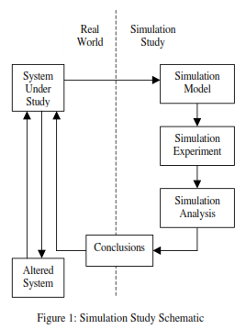
The steps involved in developing a simulation model, designing a simulation experiment, and performing simulation analysis are:
Step 1. Identify the problem.
Step 2. Formulate the problem.
Step 3. Collect and process real system data.
Step 4. Formulate and develop a model.
Step 5. Validate the model.
Step 6. Document model for future use.
Step 7. Select appropriate experimental design.
Step 8. Establish experimental conditions for runs.
Step 9. Perform simulation runs.
Step 10. Interpret and present results.
Step 11. Recommend further course of action.
Although this is a logical ordering of steps in a simulation study, many iterations at various sub-stages may be required before the objectives of a simulation study are achieved. Not all the steps may be possible and/or required. On the other hand, additional steps may have to be performed. The next three sections describe these steps in detail.
HOW TO DEVELOP A SIMULATION MODEL
Simulation models consist of the following components system entities, input variables, performance measures, and functional relationships. For instance in a simulation model of an M/M/1 queue, the server and the queue are system entities, arrival rate and service rate are input variables, mean wait time and maximum queue length are performance measures, and 'time in system = wait time + service time' is an example of a functional relationship. Almost all simulation software packages provide constructs to model each of the above components. Modeling is arguably the most important part of a simulation study. Indeed, a simulation study is as good as the simulation model. Simulation modeling comprises the following steps:
Step 1. Identify the problem. Enumerate problems with an existing system. Produce requirements for a proposed system.
Step 2. Formulate the problem. Select the bounds of the system, the problem or a part thereof, to be studied. Define overall objective of the study and a few specific issues to be addressed. Define performance measures - quantitative criteria on the basis of which different system configurations will be compared and ranked. Identify, briefly at this stage, the configurations of interest and formulate hypotheses about system performance. Decide the time frame of the study, i.e., will the model be used for a one-time decision (e.g., capital expenditure) or over a period of time on a regular basis (e.g., air traffic scheduling). Identify the end user of the simulation model, e.g., corporate management versus a production supervisor. Problems must be formulated as precisely as possible.
Step 3. Collect and process real system data.
Collect data on system specifications (e.g., bandwidth for a communication network), input variables, as well as performance of the existing system. Identify sources of randomness in the system, i.e., the stochastic input variables. Select an appropriate input probability distribution for each stochastic input variable and estimate corresponding parameter(s). Software packages for distribution fitting and selection include ExpertFit, BestFit, and add-ons in some standard statistical packages. These aids combine goodness-of-fit tests, e.g., test, Kolmogorov-Smirnov test, and Anderson-Darling test, and parameter estimation in a user friendly format. Standard distributions, e.g., exponential, Poisson, normal, hyperexponential, etc., are easy to model and simulate. Although most simulation software packages include many distributions as a standard feature, issues relating to random number generators and generating random variates from various distributions are pertinent and should be looked into. Empirical distributions are used when standard distributions are not appropriate or do not fit the available system data. Triangular, uniform or normal distribution is used as a first guess when no data are available.
Step 4.Formulate and develop a model.
Develop schematics and network diagrams of the system (How do entities flow through the system?). Translate these conceptual models to simulation software acceptable form. Verify that the simulation model executes as intended. Verification techniques include traces, varying input parameters over their acceptable range and checking the output, substituting constants for random variables and manually checking results, and animation.
Step 5.Validate the model.
Compare the model's performance under known conditions with the performance of the real system. Perform statistical inference tests and get the model examined by system experts. Assess the confidence that the end user places on the model and address problems if any. For major simulation studies, experienced consultants advocate a structured presentation of the model by the simulation analyst(s) before an audience of management and system experts. This not only ensures that the model assumptions are correct, complete and consistent, but also enhances confidence in the model.
Verification pertains to the computer program prepared for the simulation model. Is the computer program performing properly? With complex models, it is difficult, if not impossible; to translate a model successfully in its entirety without a good deal of debugging; if the input parameters and logical structure of the model are correctly represented in the computer, verification has been completed. For the most part, common sense is used in completing this step.
Validation usually is achieved through the calibration of the model, an iterative process of comparing the model against actual system behavior and using the discrepancies seen the two, and the insights gained, to improve the model. This process is repeated until model accuracy is judged acceptable. In the example of a bank previously mentioned, data was collected concerning the length of waiting line under the current conditions. Does the simulation model replicate this system measure?

Step 6.Document model for future use. Document objectives, assumptions and input variables in detail.
.
Step 7.Select appropriate experimental design.
Select a performance measure, a few input variables that are likely to influence it, and the levels of each input variable. When the number of possible configurations (product of the number of input variables and the levels of each input variable) is large and the simulation model is complex, common second-order design classes including central composite, Box-Behnken, and full factorial should be considered. Document the experimental design.
Step 8.Establish experimental conditions for runs.
Address the question of obtaining accurate information and the most information from each run. Determine if the system is stationary (performance measure does not change over time) or non-stationary (performance measure changes over time). Generally, in stationary systems, steady-state behavior of the response variable is of interest. Ascertain whether a terminating or a non terminating simulation run is appropriate. Select the run length. Select appropriate starting conditions (e.g., empty and idle, five customers in queue at time 0). Select the length of the warm-up period, if required. Decide the number of independent runs - each run uses a different random number stream and the same starting conditions by
considering output data sample size. Sample size must be large enough (at least 3-5 runs for each configuration) to provide the required confidence in the performance measure estimates. Alternately, use common random numbers to compare alternative configurations by using a separate random number stream for each sampling process in a configuration. Identify output data most likely to be correlated.
Step 9.Perform simulation runs. Perform runs according to steps 7-8 above.
HOW TO PERFORM SIMULATION ANALYSIS?
Most simulation packages provide run statistics (mean, standard deviation, minimum value, maximum value) on the performance measures, e.g., wait time (non-time persistent statistic), inventory on hand (time persistent statistic). Let the mean wait time in an M/M/1 queue observed from n runs be W...,,W,W It is important to understand that the mean wait time W is a random variable and the objective of output analysis is to estimate the true mean of W and to quantify its variability. Notwithstanding the facts that there are no data collection errors in simulation, the underlying model is fully known, and replications and configurations are user controlled, simulation results are difficult to interpret. An observation may be due to system characteristics or just a random occurrence. Normally, statistical inference can assess the significance of an observed phenomenon, but most statistical inference techniques assume independent, identically distributed (iid) data. Most types of simulation data are autocorrelated, and hence, do not satisfy this assumption. Analysis of simulation output data consists of the following steps.
Step 10. Interpret and present results.
Compute numerical estimates (e.g., mean, confidence intervals) of the desired performance measure for each configuration of interest. To obtain confidence intervals for the mean of autocorrelated data, the technique of batch means can be used. In batch means, original contiguous data set from a run is replaced with a smaller data set containing the means of contiguous batches of original observations. The assumption that batch means are independent may not always be true; increasing total sample size and
increasing the batch length may help. Test hypotheses about system performance. Construct graphical displays (e.g., pie charts, histograms) of the output data. Document results and conclusions.
Step 11. Recommend further course of action. This may include further experiments to increase the precision and reduce the bias of estimators, to perform sensitivity analyses, etc.

WHAT MAKES A PROBLEM SUITABLE FOR SIMULATION MODELING AND ANALYSIS?
In general, whenever there is a need to model and analyze randomness in a system, simulation is the tool of choice. More specifically, situations in which simulation modeling and analysis is used include the following:
♦ It is impossible or extremely expensive to observe certain processes in the real world, e.g., next year's
cancer statistics, performance of the next space shuttle, and the effect of Internet advertising on a
company's sales.
♦ Problems in which mathematical model can be formulated but analytic solutions are either impossible (e.g., job shop scheduling problem, high order difference equations) or too complicated (e.g., complex systems like the stock market, and large scale queuing models).
♦ It is impossible or extremely expensive to validate the mathematical model describing the system, e.g.,
due to insufficient data.
Applications of simulation abound in the areas of government, defense, computer and communication
systems, manufacturing, transportation (air traffic control), health care, ecology and environment, sociological and behavioral studies, biosciences, epidemiology, services (bank teller scheduling), economics and business analysis
BENEFITS OF SIMULATION MODELING AND ANALYSIS
According to practitioners, simulation modeling and analysis is one of the most frequently used operations research techniques. When used judiciously, simulation modeling and analysis makes it possible to:
♦ Obtain a better understanding of the system by developing a mathematical model of a system of interest, and observing the system's operation in detail over long periods of time.
♦ Test hypotheses about the system for feasibility.
♦ Compress time to observe certain phenomena over long periods or expand time to observe a complex
phenomenon in detail.
♦ Study the effects of certain informational, organizational, environmental and policy changes on the operation of a system by altering the system's model; this can be done without disrupting the real system and significantly reduces the risk of experimenting with the real system.
♦ Experiment with new or unknown situations about which only weak information is available.
♦ Identify the "driving" variables - ones that performance measures are most sensitive to - and the inter-relationships among them.
♦ Identify bottlenecks in the flow of entities (material, people, etc.) or information.
♦ Use multiple performance metrics for analyzing system configurations.
♦ Employ a systems approach to problem solving.
♦ Develop well designed and robust systems and reduce system development time.
PITFALLS TO GUARD AGAINST IN SIMULATION?
Simulation can be a time consuming and complex exercise, from modeling through output analysis, that
necessitates the involvement of resident experts and decision makers in the entire process. Following is a
checklist of pitfalls to guard against.
♦ Unclear objective.
♦ Using simulation when an analytic solution is appropriate.
♦ Invalid model.
♦ Simulation model too complex or too simple.
♦ Erroneous assumptions.
♦ Undocumented assumptions. This is extremely important and it is strongly suggested that assumptions made at each stage of the simulation modeling and analysis exercise be documented thoroughly.
♦ Using the wrong input probability distribution.
♦ Replacing a distribution (stochastic) by its mean (deterministic).
♦ Using the wrong performance measure.
♦ Bugs in the simulation program.
♦ Using standard statistical formulas that assume
independence in simulation output analysis.
♦ Initial bias in output data.
♦ Making one simulation run for a configuration. Poor schedule and budget planning.
♦ Poor communication among the personnel involved in the simulation study

Discrete-Event versus Continuous Simulation
Two broad categories of simulations are discrete-event and continuous simulations. A discrete-event simulation is one where changes in the state of the system occur instantaneously at random points in time as a result of the occurrence of discrete events. For example, in a queueing system where the state of the system is the number of customers in the system, the discrete events that change this state are the arrival of a customer and the departure of a customer due to the completion of its service. Most applications of simulation in practice are discrete-event simulations.
A continuous simulation is one where changes in the state of the system occur continuously over time. For example, if the system of interest is an airplane in flight and its state is defined as the current position of the airplane, then the state is changing continuously over time. Some applications of continuous simulations occur in design studies of such engineering systems.
Continuous simulations typically require using differential equations to describe the rate of change of the state variables. Thus, the analysis tends to be relatively complex. By approximating continuous changes in the state of the system by occasional discrete changes, it often is possible to use a discrete-event simulation to approximate the behavior of a continuous system. This tends to greatly simplify the analysis. This chapter focuses hereafter on discrete-event simulations. We assume this type in all subsequent references to simulation. Now let us look at two examples to illustrate the basic ideas of simulation. These examples have been kept considerably simpler than the usual application of this technique in order to highlight the main ideas more readily. The first system is so simple, in fact, that the simulation does not even need to be performed on a computer. The second system incorporates more of the normal features of a simulation, although it, too, is simple enough to be solved analytically
A Coin Flipping Game
You are the lucky winner of a sweepstakes contest. Your prize is an all-expense-paid vacation at a major otel in Las Vegas, including some chips for gambling in the hotel casino. Upon entering the casino, you find that, in addition to the usual games (blackjack, roulette, etc.), they are offering an interesting new game with the following rules.
Rules of the Game.
1. Each play of the game involves repeatedly flipping an unbiased coin until the difference between the number of heads tossed and the number of tails is 3.
2. If you decide to play the game, you are required to pay $1 for each flip of the coin You are not allowed to quit during a play of the game.
3. You receive $8 at the end of each play of the game.
Thus, you win money if the number of flips required is fewer than 8, but you lose money if more than 8 flips are required. Here are some examples (where H denotes a head and T a tail).
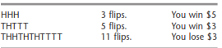
How would you decide whether to play this game?
Many people would base this decision on simulation, although they probably would not call it by that name. In this case, simulation amounts to nothing more than playing the game alone many times until it becomes clear whether it is worthwhile to play for money. Half an hour spent in repeatedly flipping a coin and recording the earnings or losses that would have resulted might be sufficient. This is a true simulation because you are imitating the actual play of the game without actually winning or losing any money.
Now let us see how a computer can be used to perform this same simulated experiment. Although a computer cannot flip coins, it can simulate doing so. It accomplishes this by generating a sequence of random observations from a uniform distribution between 0 and 1, where these random observations are referred to as uniform random numbers over the interval [0, 1].
SOME COMMON TYPES OF APPLICATIONS OF SIMULATION
Simulation is an exceptionally versatile technique. It can be used (with varying degrees of difficulty) to investigate virtually any kind of stochastic system. This versatility has made simulation the most widely used OR technique for studies dealing with such systems, and its popularity is continuing to increase. Because of the tremendous diversity of its applications, it is impossible to enumerate all the specific areas in which simulation has been used. However, we will briefly describe here some particularly important categories of applications. The first three categories concern types of stochastic systems considered in some preceding chapters. It is common to use the kinds of mathematical models described in those chapters to analyze simplified versions of the system and then to apply simulation to refine the results
Estimating the Probability of Completing a Project by the Deadline
Consequently, it is becoming increasingly common now to use simulation to obtain a better estimate of this probability. This involves generating random observations from the probability distributions of the duration of the various activities in the projects. By using the project network, it then is straightforward to simulate when each activity begins and ends, and so when the project finishes. By repeating this simulation thousands of times (in one computer run), a very good estimate can be obtained of the probability of meeting the deadline
Design and Operation of Manufacturing Systems
Surveys consistently show that a large proportion of the applications of simulation involve manufacturing systems. Many of these systems can be viewed as a queueing system of some kind (e.g., a queueing system where the machines are the servers and the jobs to be processed are the customers). However, various complications inherent in these systems (e.g., occasional machine breakdowns, defective items needing to be reworked, and multiple types of jobs) go beyond the scope of the usual queueing models. Such complications are no problem for simulation.
Here are a few examples of the kinds of questions that might be addressed.
1. How many machines of each type should be provided?
2. How many materials-handling units of each type should be provided?
3. Considering their due dates for completion of the entire production process, what rule should be used to choose the order in which the jobs currently at a machine should be processed?
4. What are realistic due dates for jobs?
5. What will be the bottleneck operations in a new production process as currently designed?
6. What will be the throughput (production rate) of a new production process?
Design and Operation of Distribution Systems
Any major manufacturing corporation needs an efficient distribution system for distributing its goods from its factories and warehouses to its customers. There are many uncertainties involved in the operation of such a system. When will vehicles become available for shipping the goods? How long will a shipment take? What will be the demands of the various customers? By generating random observations from the relevant probability distributions, simulation can readily deal with these kinds of uncertainties. Thus, it is used quite often to test various possibilities for improving the design and operation of these systems.
Financial Risk Analysis
Financial risk analysis was one of the earliest application areas of simulation, and it continues to be a very active area. For example, consider the evaluation of a proposed capital investment with uncertain future cash flows. By generating random observations from the probability distributions for the cash flow in each of the respective time periods (and considering relationships between time periods), simulation can generate thousands of scenarios for how the investment will turn out. This provides a probability distribution of the eturn (e.g., net present value) from the investment. This distribution (sometimes called
the risk profile) enables management to assess the risk involved in making the investment. A similar approach enables analyzing the risk associated with investing in various securities, including the more exotic financial instruments such as puts, calls, futures, stock options, etc
Health Care Applications
Health care is another area where, like the evaluation of risky investments, analyzing future uncertainties is central to current decision making. However, rather than dealing with uncertain future cash flows, the uncertainties now involve such things as the evolution of human diseases. Here are a few examples of the kinds of computer simulations that have been performed to guide the design of health care systems.
1. Simulating the use of hospital resources when treating patients with coronary heart disease.
2. Simulating health expenditures under alternative insurance plans.
3. Simulating the cost and effectiveness of screening for the early detection of a disease.
4. Simulating the use of the complex of surgical services at a medical center.
5. Simulating the timing and location of calls for ambulance services.
6. Simulating the matching of donated kidneys with transplant recipients.
7. Simulating the operation of an emergency room.
Queuing Theory
Queues are a part of everyday life. We all wait in queues to buy a movie ticket, to make bank
deposit, pay for groceries, mail a package, obtain a food in a cafeteria, to have ride in an amusement park and have become adjustment to wait but still get annoyed by unusually long
waits.
The Queuing models are very helpful for determining how to operate a queuing system in the
most effective way if too much service capacity to operate the system involves excessive costs.
The models enable finding an appropriate balance between the cost of service and the amount
of waiting.
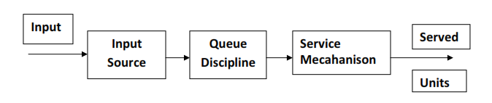

Characteristics of Queuing System
The characteristics listed below would provide sufficient information.
1. The arrival pattern.
2. The service mechanism.
3. The queue discipline.
4. The number of customers allowed in the system.
5. The number of service channels
The Arrival Pattern: The arrival pattern describes how a customer may become a part of the queuing system. The arrival time for any customer is unpredictable. Therefore, the arrival time and the number of customers arriving at any specified time intervals are usually random variables. A Poisson distribution of arrivals correspond to arrivals at
random. In Poisson di stributi on, successive customers arrive after intervals which independently are and exponentially distributed. The Poisson distribution is important, as it is a suitable mathematical model of many practical queuing systems as described by the parameter “the average arrival rate”.
2. The Service Mechanism: The service mechanism is a description of resources required for service. If there are infinite number of servers, then there will be no queue. If the number of servers is finite, then the customers are served according to a specific order. The time taken to serve a particular customer is called the service time. The service time is a statistical variable and can be studied either as the number of services completed in a given period
of time or the completion period of a service.
3. The Queue Discipline: The most common queue discipline is the “First Come First Served” (FCFS) or “First-in, First-out” (FIFO). Situations like waiting for a haircut, ticket-booking counters follow FCFS discipline. Other disciplines include “Last In First Out” (LIFO) where last customer is serviced first, “Service In Random Order” (SIRO) in which the customers are serviced randomly irrespective of their arrivals. “Priority service” is when the customers are grouped in priority classes based on urgency. “Preemptive Priority” is the highest priority given to the customer who enters into the service, immediately, even if a customer with lower priority is in service. “Non-preemptive priority” is where the customer goes ahead in the queue, but will be served only after the completion of the current service.
4. The Number of Customers Allowed in the System: Some of the queuing processes allow the limitation to the capacity or size of the waiting room, so that the waiting line reaches a certain length, no additional customers is allowed to enter until space becomes available by a service completion. This type of situation means that there is a finite limit to the maximum queue size.
5. The Number of Service Channels: The more the number of service channels in the service facility, the greater the overall service rate of the facility. The combination of arrival rate and service rate is critical for determining the number of service channels. When there are a number of service channels available for service, then the arrangement of service depends upon the design of the system’s service mechanism.
Parallel channels means, a number of channels providing identical service facilities so that several customers may be served simultaneously. Series channel means a customer go through successive ordered channels before service is completed. . A queuing system is called a one-server model, i.e., when the system has only one server, and a multi-server model i.e., when the system has a number of parallel channels, each with one server.
Customer behaviour
The length of the queue or the waiting time of a customer or the idle time of the servicefacility mostly depends on the behaviour of the customer. Here the behaviour refers to theimpatience of a customer during the stay in the line. Customer behaviour can be classified as:
(i) Balking: This behaviour signifies that the customer does not like to join the queueseeing the long length of it. This behaviour may effect in loosing a customer by the organization. Always a lengthy queue indicates insufficient service facility and customer may not turn out next time. For example, a customer who wants to go by train to hisdestination goes to railway station and after seeing the long queue in front of the ticket counter, may not like to join the queue and seek other type of transport to reach hisdestination.
(ii) Reneging: In this case the customer joins the queue and after waiting for certain time looses his patience and leaves the queue. This behaviour of the customer may also cause loss of customer to the organization.
(iii) Collusion: In this case several customers may collaborate and only one of them may stand in the queue. One customer represents a group of customer. Here the queue length may be small but service time for an individual will be more. This may break the patience of the other customers in the waiting line and situation may lead to any type ofworst episode.
(iv) Jockeying: If there are number of waiting lines depending on the number of service stations, for example Petrol bunks, Cinema theaters, etc. A customer in one of the queue after seeing the other queue length, which is shorter, with a hope of getting the service, may leave the present queue and join the shorter queue. Perhaps the situation may be that other queue which is shorter may be having more number of Collaborated customers. In such case the probability of getting service to the customer who has changed the queue may be very less. Because of this character of the customer, the queue lengths may goes on changing from time to time.

At a given facility, the arrival enters at the service facility and is completely served by that server. The time elapsed from the commencement of the service to its completion for an unit at the service facility is known as service time usually, service time follows as exponential distribution
Classification of queuing models using kendal & Lee notations
Generally, any queuing models may be completely specified in the following symbolic form
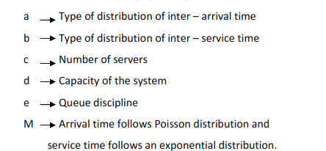
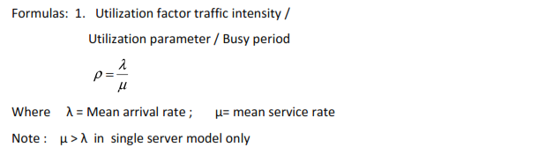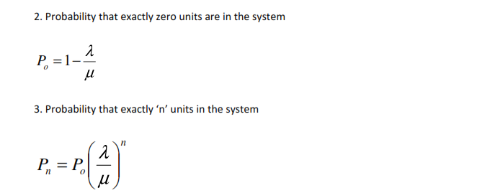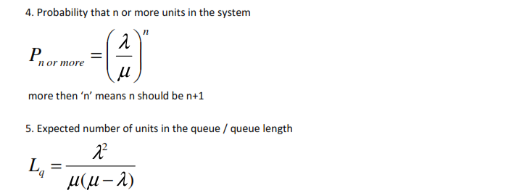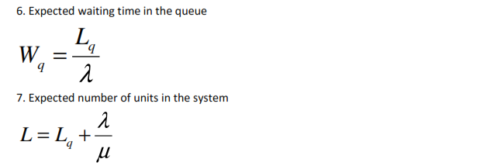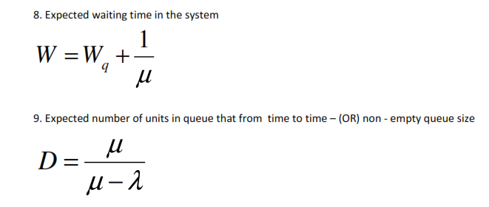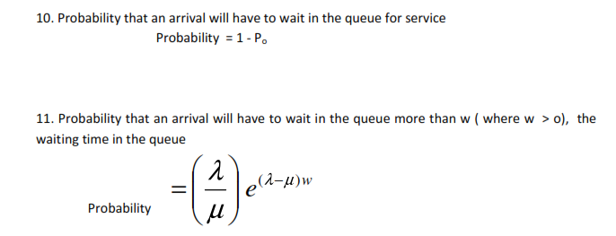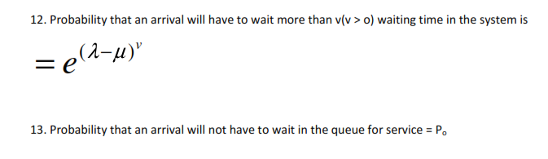
Problems
1. Arrivals at a telephone both are considered to be Poisson at an average time of 8 min between our arrival and the next. The length of the phone call is distributed exponentially, with a mean of 4 min.
Determine
(a) Expected fraction of the day that the phone will be in use.
(b) Expected number of units in the queue Expected waiting time in the queue.
(c) Expected number of units in the system.
(e) Expected waiting time in the system
(f) Expected number of units in queue that from time to time.
(g) What is the probability that an arrival will have to wait in queue for service?
(h) What is the probability that exactly 3 units are in system
(i) What is the probability that an arrival will not have to wait in queue for service?
(j) What is the probability that there are 3 or more units in the system?
(k) What is the probability that an arrival will have to wait more than 6 min in queue for service?
(l) What is the probability that more than 5 units in system
(m) What is the probability that an arrival will have to wait more than 8 min in system?
(n) Telephone company will install a second booth when convinced that an arrival would have
to wait for attest 6 min in queue for phone. By how much the flow of arrival is increased in
order to justify a second booth
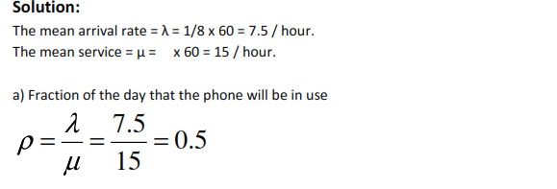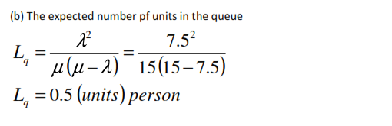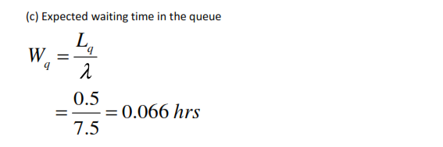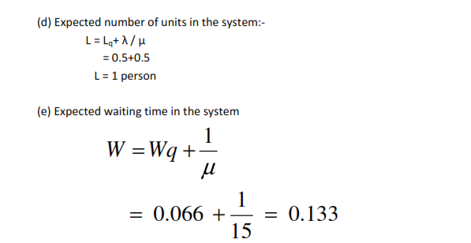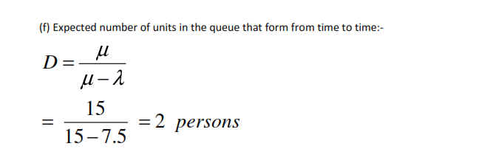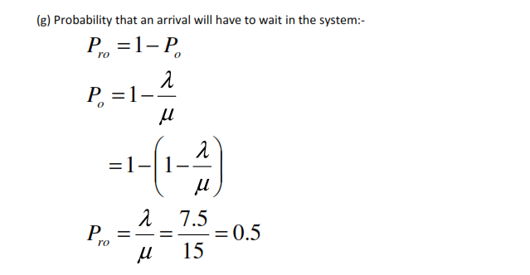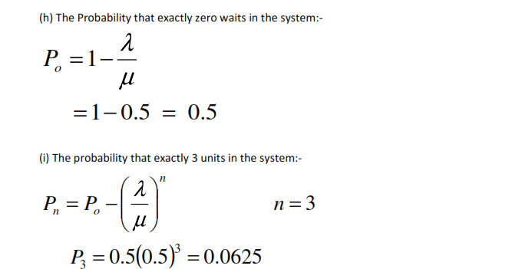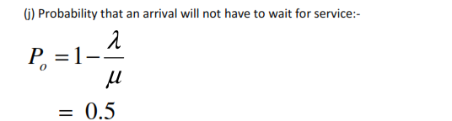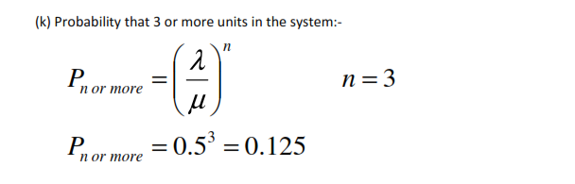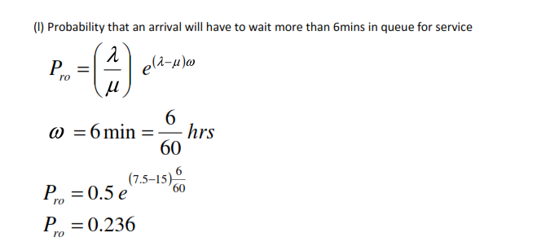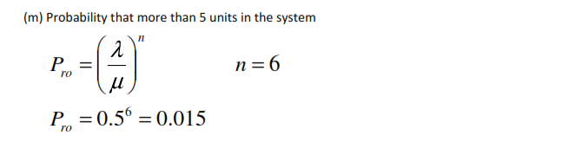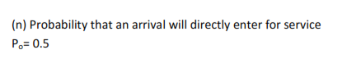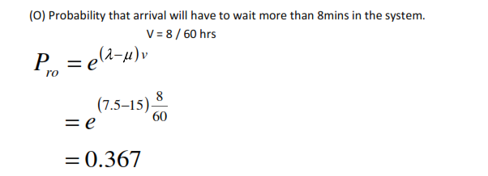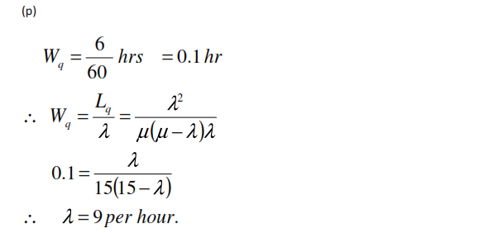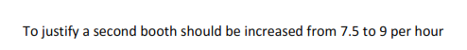
2) In a bank there is only on window. A solitary employee performs all the service required and the window remains continuously open from 7am to 1pm. It has discovered that an average number of clients is 54 during the day and the average service time is 5mins / person. Find
a) Average number of clients in the system
b) Average waiting time
c) The probability that a client has to spend more than 10mins in a system
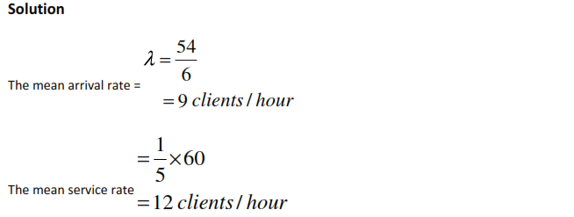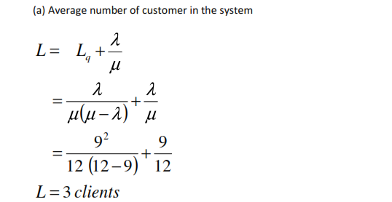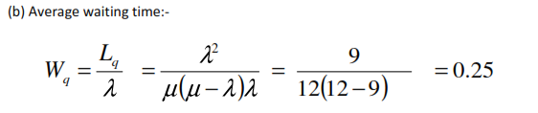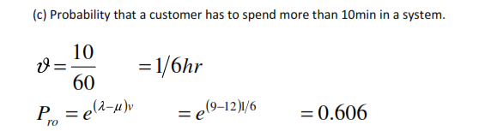
10) In a municipality hospital patient’s arrival are considered to be Poisson with an arrival interval time of 10mins. The doctors (examination and dispensing) time many be assumed to be ED with an average of 6mins find :
a) What is the chance that a new patient directly sees the doctor?
b) For what proportion of the time the doctor is busy?
c) What is the average number of patients in the system?
d) What is the average waiting time of the system?
e) Suppose the municipality wants to recruit another doctor, when an average waiting time of an arrival is 30mins in the queue. Find out hose large should be to justify a 2 doctor?
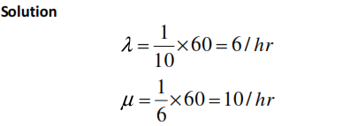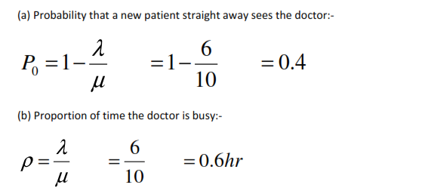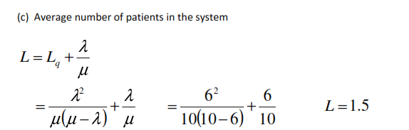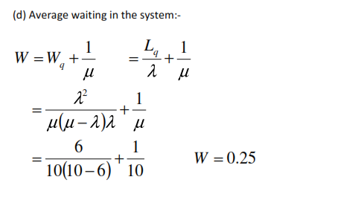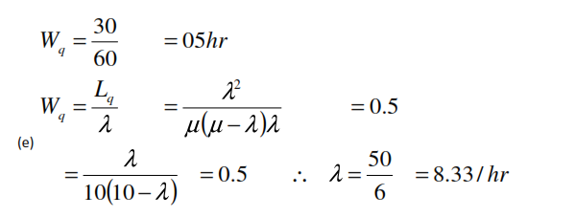
11) At a one man barber shop customers arrive according to P.D with a mean arrival rate of 5/hr. The hair cutting time is ED with a hair cut taking 10 min on an average assuming that the customers are always willing to wait find:
a) Average number of customer in the shop [5]
b) Average waiting time of a customer [0.833]
c) The percent of time an arrival Can walkright with out having to wait [16.66%]
d) The probability of a customer waiting more than 5mins [0.766]
12) At a stamp vender window of a post office 20 customers arrive on an average every 10 min.
the vender clerk can serve 5 customers in 2 min. Determine
a)Average number of customer in the System [4]

b) Average waiting time of a customer [0.0266]
c) Probability of a customer waiting more than 3mins before being served[0.1785]
d) Idle time of the vender clerk in a shift of 8hrs [1.6]
14) Jobs arrive at an inspection station according to Poisson process at a mean rate of 2/hr and are inspect one at a time on a FIFO basis. The quality control engineer both inspects and makes minor adjustments. The total service time for the job appears to be ED with a mean of 25mins.
Jobs that arrive but cannot be inspected immediately by the engineer must be stored until the engineer is free to take them. Each job requires 1 sq mts space determine
a) The waiting line length
[4.16]
b) The waiting time
[2.08]
c) % of idle time of the engineer [16.66%]
d) The floor space to be provided in the quality control room. [5]

MONTE-CARLO SIMULATION
The Monte-Carlo method is a simulation technique in which statistical distribution functions are created using a series of random numbers. Working on the digital computer for a few minutes we can create data for months or years. The method is generally used to solve problems which cannot be adequately represented by mathematical models or where solution of the model is not possible by analytical method.
Monte-Carlo simulation yields a solution, which should be very close to the optimal, but not necessarily the exact solution. But this technique yields a solution, which converges to the optimal solution as the number of simulated trials tends to infinity.
.Simulation can also be defined as a technique of performing sampling experiments on the model of the system. This is called stochastic simulation and is a part of simulation techniques. Because sampling from a particular probability distribution involves the use of random numbers, stochastic simulation is sometimes called Monte Carlo Simulation. Historically, Monte Carlo method is considered to be a technique, using random or pseudo random numbers. It is important to know what random numbers are. Let us take a simple example of tossing a coin. If coin is unbiased, probability of coming head is 0.5. If we generate two numbers say, 0 and 1, so that occurrence of both is equally likely. Let us assume that number 1 depicts head and 0, tail. These numbers are called uniform random numbers. We will discuss stochastic simulation in chapter four.
We give below some differences between the Monte Carlo method and simulation:
1. In the Monte Carlo method, time does not play as substantial role, a role as it does in stochastic simulation.
2. The observations in the Monte Carlo method, as a rule, are independent. In simulation, however, we experiment with the model over time so, as a rule, the observations are serially correlated.
3. In the Monte Carlo method, it is possible to express the response as a rather simple function of the stochastic input variants. In simulation the response is usually a very complicated one and can be expressed explicitly only by the computer program itself.
The Monte-Carlo simulation procedure can be summarized in the following steps:
Step 1: Clearly define the problem:
(a) Identify the objectives of the problem.
(b) Identify the main factors, which have the greatest effect on the objective of the problem.
Step 2: Construct an approximate model:
(a) Specify the variables and parameters of the mode.
(b) Formulate the appropriate decision rules, i.e. state the conditions under which the experiment
is to be performed.
(c) Identify the type of distribution that will be used. Models use either theoretical distributions
or empirical distributions to state the patterns of the occurrence associated with the variables.
(d) Specify the manner in which time will change

GENERATION OF RANDOM NUMBERS
implementing a simulation model requires random numbers to obtain random observations from probability distributions. One method for generating such random numbers is to use a physical device such as a spinning disk or an electronic randomizer. Several tables of random numbers have been generated in this way, including one containing 1 million random digits, published by the Rand Corporation. An excerpt from the Rand table is given in Table 22.3.
Physical devices now have been replaced by the computer as the primary source for generating random numbers. For example, Excel uses the RAND() function for this purpose. Many other software packages also have the capability of generating random numbers whenever needed during a simulation run.

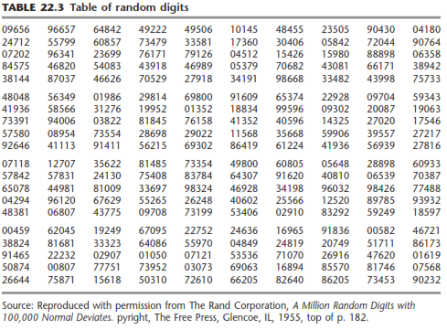
RANDOM NUMBERS Simulation using an electronic device requires algorithms that produce streams of numbers that a user cannot distinguish from a similar string of numbers generated randomly. This is normally done using algorithms that generate numbers between 0 and 1, called a random number generator. This chapter will look at some of the properties and applications of such generators. 2.1 Pseudo-Random Numbers To be useful in simulation, a sequence of random numbers �!, �!, … must have two important properties: uniformity and independence. That is, each random number �! is an independent sample drawn from a continuous uniform distribution between 0 and 1 (mean 1/2, standard deviation 1/12). Some consequences of the uniformity and independence properties are the following: 1. If the interval [0, 1] is divided into � subintervals of equal length, then the expected number of observed values in each interval is �/�, where � is the total number of observations. 2. The probability of observing a value in a particular interval is independent of the previous values observed. Simulation using a computer must use some method of generating numbers that appear to be random. These are usually called pseudo-random numbers. “Pseudo” means having a deceptive resemblance to, so the numbers generated must deceive the user to the extent that statistical tests cannot determine that they are not random. In practice, the pseudo is usually dropped, and they are (incorrectly) referred to as random numbers. There are numerous methods that have been devised and used on computers as random number generators. The following properties have been found to be useful for such routines.
1. The routine used to generate the numbers should be fast. A simulation often requires large numbers of random values, and a slow method of generation can slow the execution of the simulation to an unacceptable extent.
2. The routine should not require a lot of core storage. This is not as great a requirement as it once was, with the current generation of computers.
3. The routine should have a sufficiently long cycle. The cycle length, or period, represents the length of the random number sequence until previously generated numbers begin to repeat.
4. The random numbers should be reproducible. Being able to repeat the random numbers in the same order is very useful in comparing alternate systems.
5. Most importantly, the generated random numbers should pass statistical tests for uniformity and independence
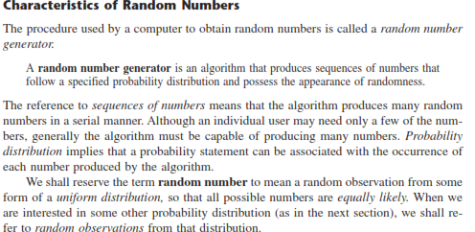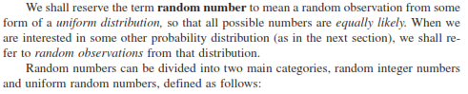
Strictly speaking, the numbers generated by the computer should not be called random numbers because they are predictable and reproducible (which sometimes is advantageous), given the random number generator being used. Therefore, they are sometimes given the name pseudo-random numbers. However, the important point is that they satisfactorily play the role of random numbers in the simulation if the method used to generate them is valid.
Various relatively sophisticated statistical procedures have been proposed for testing whether a generated sequence of numbers has an acceptable appearance of randomness. Basically the requirements are that each successive number in the sequence have an equal probability of taking on any one of the possible values and that it be statistically independent of the other numbers in the sequence
Uniform (0,1) random numbers playa key role in sampling from distributions. True (0,1) random numbers can only be generated by electronic devices. However, because simulation models are executed on the computer, the use of electronic devices to generate random numbers is much too slow for that purpose. Additionally, electronic devices are activated by laws of chance, and hence it will be impossible to duplicate the same sequence of random numbers at will. This point is important because debugging, verification, and validation of the simulation model often require duplicating the same sequence of random numbers. The only plausible way for generating (0,1) random numbers for use in simulation is based on arithmetic operations. Such numbers are not truly random because they can be generated in advance. It is thus more appropriate to refer to them as pseudo-random numbers. The most common arithmetic operation for generating (0,1) random numbers is the multiplicative congruential method
Types of random numbers
• There are three types of random numbers, quasi-, pseudo- and true- random numbers. • These different types of random numbers have different applications.
1.True Random Number: The most often used example for “truly” random numbers is the decay of a radioactive material. If a Geiger counter is put in front of such a radioactive source, the intervals between the decay events are truly random. True random numbers are gained from physical processes like radioactive decay or also rolling a dice. But rolling a dice is difficult, perhaps someone could control the dice so well to determine the outcome.
2.Pseudo Random Number: These numbers are generated by a computer or that is to say, by an algorithm and because of this not truly random. Every new number is generated from the previous ones by an algorithm. This means that the new value is fully determined by the previous ones. But, depending on the algorithm, they often have properties making them very suitable for simulations
3. Quasi Random Number : Quasi (Virtual) random numbers are not designed to appear random, rather to be uniformly distributed. One aim of such numbers is to reduce and control errors in Monte Carlo simulations.

Pseudo Random Numbers
• Pseudo means false, so false random numbers are being generated.
• The goal of any generation scheme is to produce a sequence of numbers between zero and 1 which simulates, or imitates, the ideal properties of uniform distribution and independence as closely as possible.
• It is not possible to generate a perfect random number that is the random numbers are generated by some known arithmetic operations or formulas which is pseudorandom number or false random number.
• Since the arithmetic operation is known and the sequence of random numbers can be repeated, the numbers cannot be called truly random number.
• However the pseudo-random numbers generated by many computer routines very closely fulfill the requirement of desired randomness.
When generating pseudo-random numbers, certain problems or errors can occur. Some examples include the following: • The generated numbers may not be uniformly distributed. • The generated numbers may be discrete-valued instead continuous valued. { Numbers are discrete valued and not continuous on [0,1] } • The mean of the generated numbers may be too high or too low. • The variance of the generated numbers may be too high or low. • There may be dependence. The following are the examples: a) Autocorrelation between numbers. b) Numbers successively higher or lower than adjacent numbers. c) Several numbers above the mean followed by several numbers below the mean.
Properties of Good random Number Generators
1. The routine should be fast. The total cost can be managed by selecting a computationally efficient method of random-number generation.
2. The routine should be portable to different computers, and ideally to different programming languages .This is desirable so that the simulation program produces the same results wherever it is executed.
3. The routine should have a sufficiently long cycle. The cycle length, or period, represents the length of the randomnumber sequence before previous numbers begin to repeat themselves in an earlier order. Thus, if 10,000 events are to be generated, the period should be many times that long; a special case cycling is degenerating. A routine degenerates when the same random numbers appear repeatedly. Such an occurrence is certainly unacceptable. This can happen rapidly with some methods.
4 . The random numbers should be replicable. Given the starting point (or conditions), it should be possible to generate the same set of random numbers, completely independent of the system that is being simulated. This is helpful for debugging purpose and is a means of facilitating comparisons between systems.
5. Most important, and as indicated previously, the generated random numbers should closely approximate the ideal statistical properties of uniformity and independences
TESTING OF RANDOM NUMBERS
Testing for Randomness The desired properties of random numbers are uniformity and independence. So, the test of random numbers means uniformity and independence test. There are different types of test used for these purpose. They are as follows:
1. Frequency test: Uses the Kolmogorov-Smirnov (KS) or Chi-square test to compare the distribution of the set of numbers generated to a uniform distribution
2. Runs test: Tests the runs up and down or the runs above or below the mean by comparing the actual value to expected value. The statistics for comparison in Chi-square.
3. Auto correlation test: Tests the correlation between numbers and compares the sample correlation to the expected correlation of zero.
4. Gap test: Counts the number of digits that appear between repetition of a particular digit and then uses KS test to compare with the expected size of gaps.
5. Poker test: Treats numbers group together as a poker hand. Then the hands obtained are compared to what is expected using the Chi-square test.
Method / Techniques to Generate Random Numbers Congruence or Residue Method (Uniform - Linear Congruential Method)
The linear congruential method, initially proposed by Lehrer [1951], produces a sequence of integers, X1, X2,... between zero and m — 1 according to the following recursive relationship: Xi+1 = (aXi + c) mod m…………………….(i) The initial value X0 is called the seed, a is called the constant multiplier, c is the increment, and m is the modulus.
Additive Congrutial Method : a =1 Here , Xi+1 = (Xi + c) mod m Let c = 17 , m = 29 & X0 = 7 Then , X1 = (X0 + c) mod m = ( 7 + 17) mod 29 = 24 mod 29 = 24 X2 = (X1 + c) mod m = ( 24 + 17) mod 29 = 41 mod 29 = 12 And X3=0 , X4=17, X5=5 Hence, random number are 7,24,12,0,17,5,22,10,27…..
Multiplicative Congruential Method: c = 0 Here , Xi+1 = (aXi ) mod m Let a = 9 , m = 31 & X0 = 2 Then , X1 = (aX0 ) mod m = ( 9 X 2) mod 31 = 18 mod 31 = 18 X2 = (aX1 ) mod m = ( 9 X 18) mod 31 = 162 mod 31 = 7 And X3=1 , X4=9, X5=19 Hence, random number are 2,18,7,1,9,19,16,20…..
Mixed Congruential Method: c ≠ 0 Here , Xi+1 = (aXi + c) mod m Let a = 9, c = 3 , m = 31 & X0 = 2 Then , X1 = (aX0 + c) mod m = ( 9 X 2 + 3) mod 31 = 21 mod 31 = 21 X2 = (aX1 + c) mod m = ( 9 X 21 + 3) mod 31 = 192 mod 31 = 6 And X3=26 , X4=20, X5=28 Hence, random number are 2,21,6,26,20,28,7,4,8
In this method random number are generated by the eq: Xi+1 = (Xi-1 + Xi ) mod m Let , X1=9, X2=13, m=17 X3=(X1 + X2 ) mod m = (9 + 13) mod 17 = 5 X4=(X2 + X3 ) mod m = (13 + 5) mod 17 = 1 ……………….. So The random numbers are 9,13,5,1,6,7,13,3………..

SIMULATION OF QUEUEING SYSTEMS

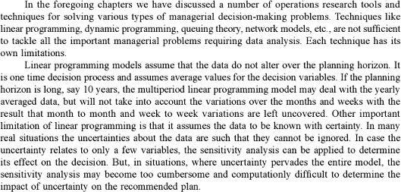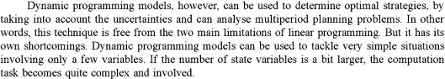
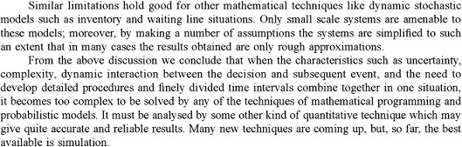

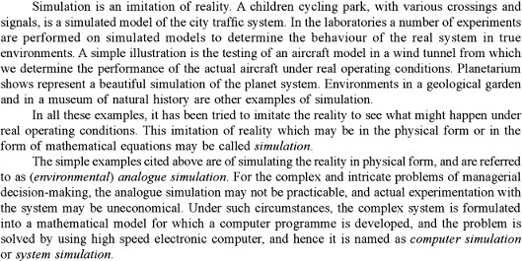
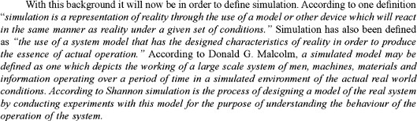
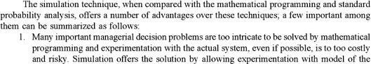
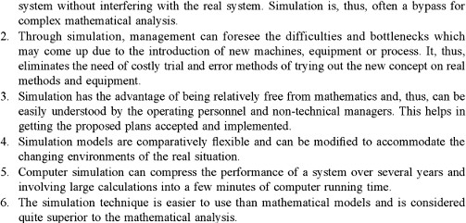

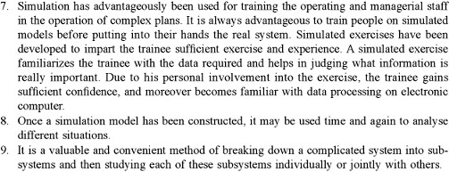

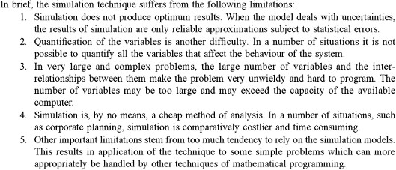
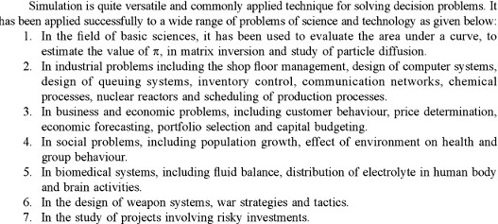

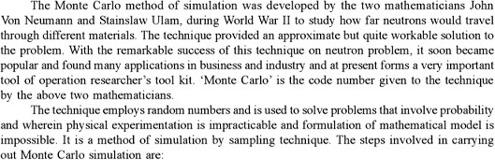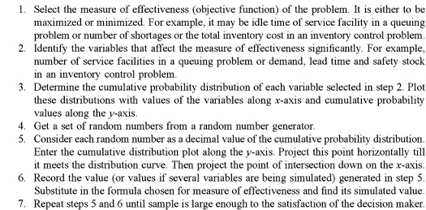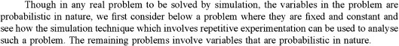

A queueing system is described by its calling population, the nature of the arrivals, the service mechanism, the system capacity, and the queueing discipline.
A simple single-channel queueing system is portrayed in Figure 2. 1. In the single-channel queue, the calling population is infinite; that is, if a unit leaves the calling population and joins the waiting line or enters service, there is no change in the arrival rate of other units that could need service. Arrivals for service occur one at a time in a random fashion; once they join the waiting line, they are eventually served. In addition, service times are of some random length according to a probability distribution which does not change over time. The system capacity has no limit, meaning that any number of units can wait in line. Finally, units are served in the order of their arrival (often called FlFO: first in, first out) by a single server or channel.
Arrivals and services are defined by the distribution of the time between arrivals and the distribution of service times, respectively. For any simple single- or multichannel queue, the overall effective arrival rate must be less than the total service rate, or the waiting line will grow without bound. When queues grow without bound, they are termed "explosive" or unstable. (In some re-entrant queueing networks in which units return a number of times to the same server before finally exiting from the system, the condition that arrival rate be less than service rate might not guarantee stability. Interestingly, this type of instability was noticed first, not in theory, but in actual manufacturing in semiconductor manufacturing plants.) More complex situations can occur-for example, arrival rates that are greater than service rates for short periods of time, or networks of queues with routing. However, this chapter sticks to the most basic queues.
after a service is completed. These two possibilities are shown as the shaded portions of Figure 2.5. It is impossible for the server to become busy if the queue is empty when a service is completed. Similarly, it is impossible for the server to be idle after a service is completed when the queue is not empty. Now, how can the events described above occur in simulated time? Simulations of queueing systems generally require the maintenance of an event list for determining what happens next. The event list tracks the future times at which the different types of events occur. This section simplifies the simulation by tracking each unit explicitly. Simulation clock times for arrivals and departures are computed in a simulation table customized for each problem. In simulation, events usually occur at random times, the randomness imitating uncertainty in real life. For example, it is not known with certainty when the next customer will arrive at a grocery checkout counter, or how long the bank teller will take to complete a transaction. In these cases, a statistical model of the data is developed either from data collected and analyzed or from subjective estimates and assumptions.
The randomness needed to imitate real life is made possible through the use of "random numbers." Random numbers are distributed unifonnly and independently on the interval (0, 1). Random digits are uniformly distributed on the set {0, l, 2, ... , 9}. Random digits can be used tofoirn random numbers by selecting the proper number of digits for each random number and placing a decimal point to the left of the value selected. The proper number of digits is dictated by the accuracy of the data being used for input purposes. If the input distribution has values with two decimal places, two digits are taken from a random digits table and the decimal point is placed to the left to form a random number.
Random numbers also can be generated in simulation packages and in spreadsheets (such as Excel). For example, Excel has a macro function called RANDO that returns a "random" number between 0 and 1. When numbers are generated by using a procedure, they are often referred to as pseudo-random numbers. Because the procedure is fully known, it is always possible to predict the sequence of numbers that will be generated prior to the simulation. In a single-channel queueing simulation, inter arrival times and service times are generated from the distributions of these random variables. The examples that follow show how such times are generated. For simplicity, assume that the times between arrivals were generated by rolling a die five times and recording the up face. Table 2.2 contains a set of five inter arrival times generated in this manner. These five inter arrival times are used to compute the arrival times of six customers at the queueing system.
During some time periods, two customers are in the system, such as at clock time 8, when customers 3 and 4 are both in the system. Also, there are times when events occur simultaneously, such as at clock time 9, when customer 5 arrives and customer 3 departs.
Problem:
As a first example we look at a simple queue model which has an infinite population,
one queue, and one server
Suppose inter-arrival times are determined by rolling a die. If the numbers 6, 1, 4, 3, 6,
5 are rolled this means that the customers arrive at times 0,6,7,11,14,20,25 as in the following table:
Worked Example
On the following pages we will go through a single queue system in some detail. We
consider a server model with inter-arrival times between 1 and 8 time units. The
probability of each time interval of length 1 is 1/8. We will use random numbers to
generate customer arrivals as follows:

SIMULATED WORKSHEET

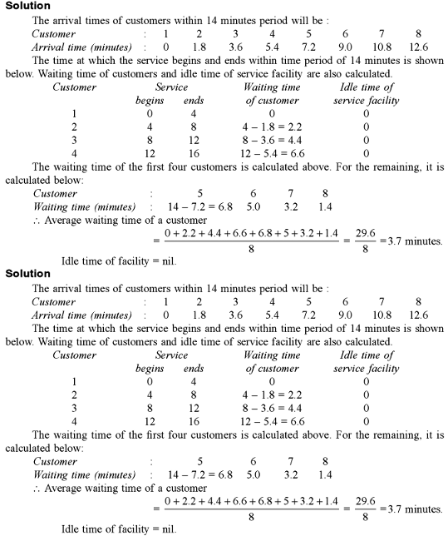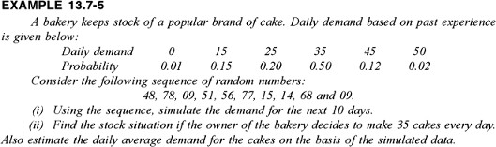

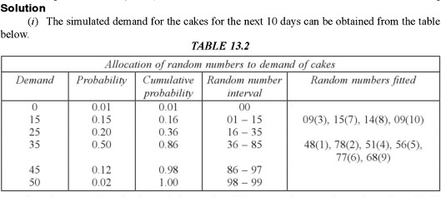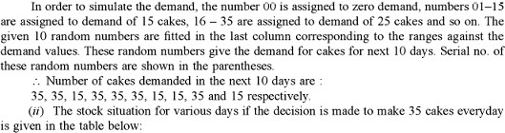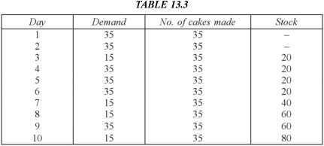
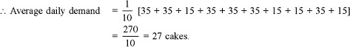

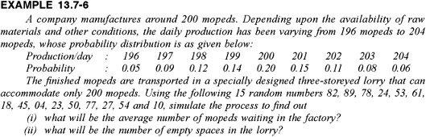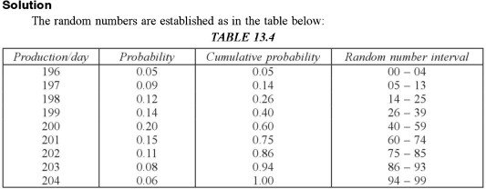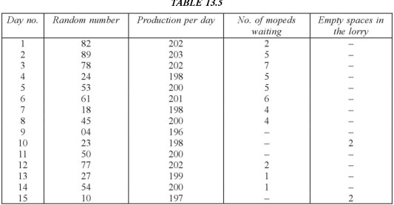
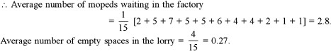

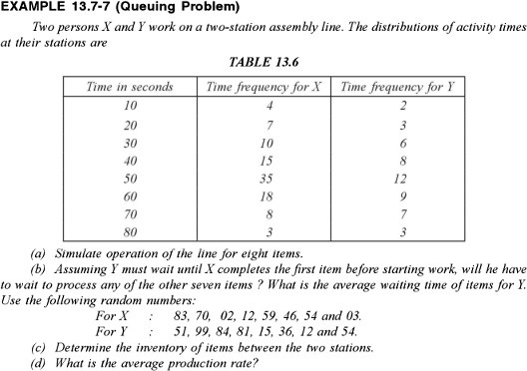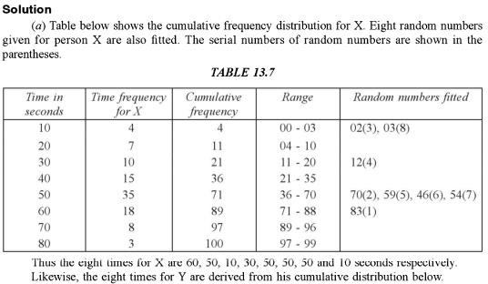

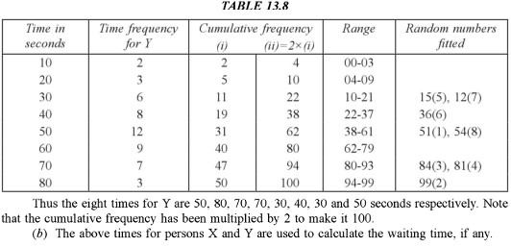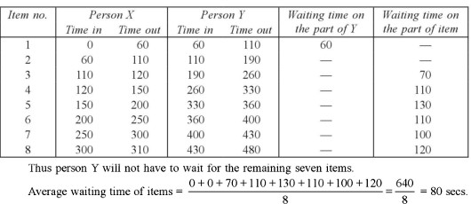
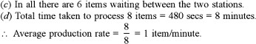

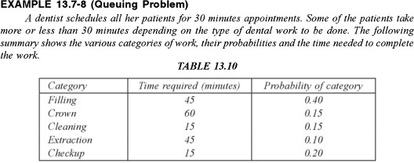

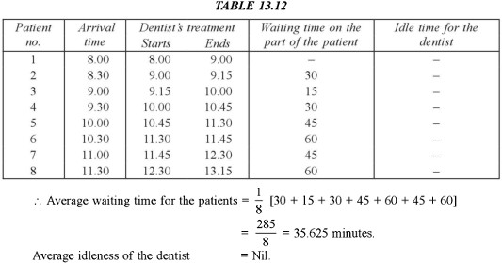
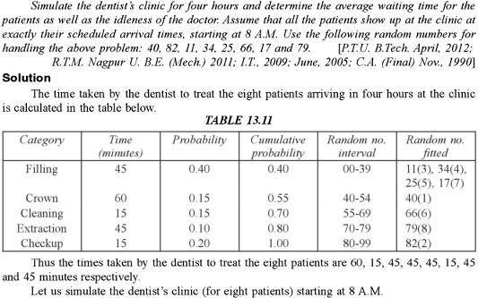

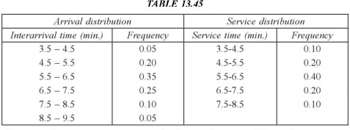

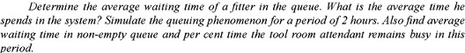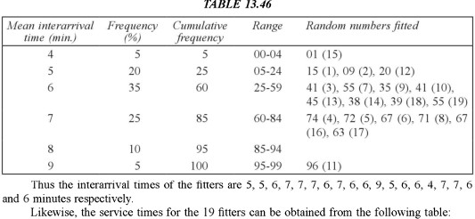
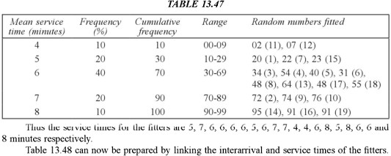
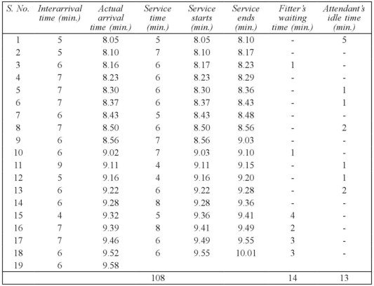

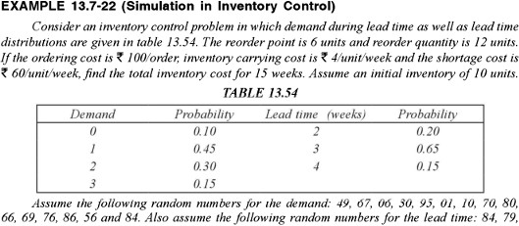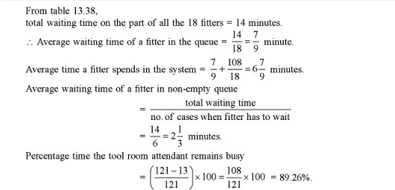
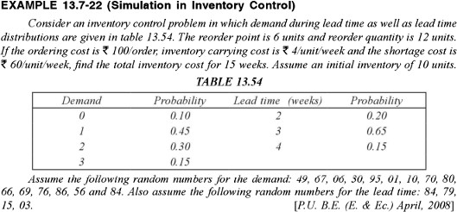
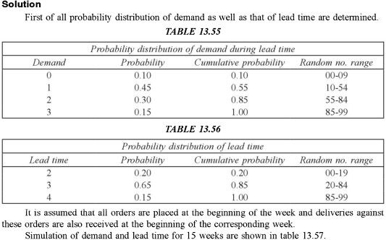

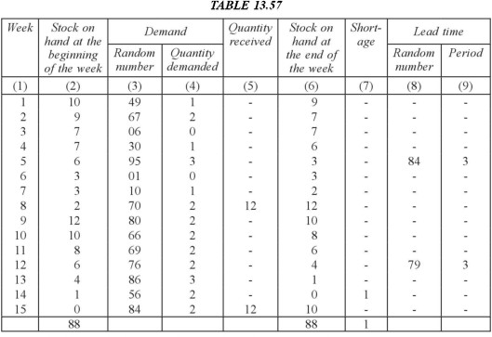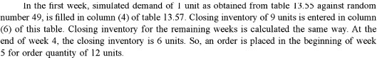

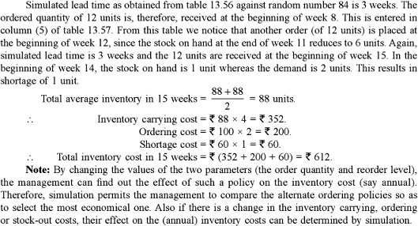

SIMULATION LANGUAGES
Execution of simulation models entails two distinct types of computations: (1) file manipulations that deal with the chronological storage and processing of model events, and (2) arithmetic and bookkeeping computations associated with generation of random samples and collection of model statistics. The first type of computation involves extensive logic development in list processing, and the second type entails tedious and time-consuming . The nature of these computations makes the computer an essential tool for
executing simulation models, and, in turn, prompts the development of special computer simulation languages for performing these computations conveniently and efficiently. Available discrete simulation languages fall into two broad categories:
1. Event scheduling
2. Process oriented
In event scheduling languages, the user details the actions associated with the occurrence of each event, in much the same way they are given . The main role of the language in this case is (1) automation of sampling from distributions, (2) storage and retrieval of events in chronological order, and (3) collection of model statistics.
Process-oriented languages use blocks or nodes that can be linked together to form a network that describes the movements of transactions or entities (i.e., customers) in the system. For example, the three most prominent blocks/nodes in any process-simulation language are a source from which transactions are created, a queue where they can wait if necessary, and a facility where service is performed. Each of
these blocks/nodes is defined with all the information needed to drive the simulation automatically. For example, once the inter arrival time for the source is specified, a process-oriented language automatically "knows" when arrival events will occur. In effect, each block/node of the model has standing instructions that define how and when transactions are moved in the simulation network. Process-oriented languages are internally driven by the same actions used in event-scheduling languages. The difference is that these actions are automated to relieve the user of the tedious computational and logical details. In a way, we can regard process-oriented languages as being based on the input-output concept of the "black box" approach. This essentially means that process-oriented languages trade modeling flexibility for simplicity and ease of use. Prominent event-scheduling languages include SIMSCRIPT, SLAM, and SIMAN. Over
the years, these languages have evolved to include process-oriented capabilities. All three languages allow the user to write (a portion of) the model in higher-level language, such as FORTRAN or C. This capability is necessary to allow the user to model complex logic that otherwise cannot be achieved directly by the regular facilities of these languages. A major reason for this limitation is the restrictive and perhaps convoluted manner in which these languages move transactions (or entities) among the model's queues and facilities. Several modern commercial packages currently dominate the simulation market,
including Arena, AweSim, and GPSS/H, to mention only a few. These packages use extensive user interface to simplify the process of creating a simulation model. They also provide animation capabilities where changes in the system can be observed visually. However, to the experienced user, these interfaces may appear to reduce the development of a simulation model to a "slow-motion" pace. It is not surprising that some users prefer to write simulation models in such general programming languages as C, Basic, and FORTRAN.
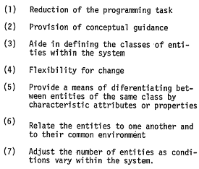
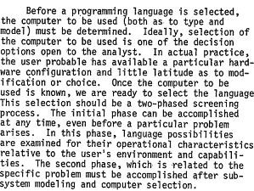
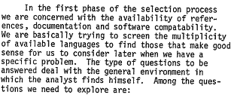
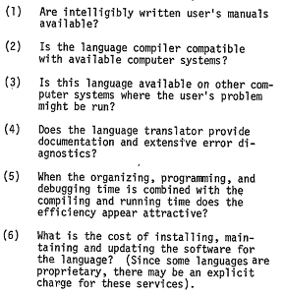

Discrete Simulation Language
Discrete simulation deals with systems whose dynamics can be considered (due to the level of abstraction) as a sequence of events at discrete time points. The key point of a discrete simulation language is the way it controls the proper sequencing of activities in the model. This is also the way a user must "view the world" when using the language and a base for classification of discrete simulation languages.

Classification of Discrete Simulation Languages
Discrete simulation language can be classified in four ways which described below
1.Flowchart Oriented Languages
2.Activity Oriented Languages
3.Event Oriented Languages
4.Process Oriented Languages

1. Flowchart Oriented Languages
Flowchart oriented languages are represented by the language GPSS (General Purpose Simulation System), that exists in many versions on various computers. The user must view the dynamics of the system as a flow of the so-called transactions through a block diagram. Transactions are generated; follow a path through a network of blocks, and are destroyed on exit. In blocks transactions may be delayed, processed, and passed to other blocks. Blocks are in the program represented by statements that perform the activities of the model.
2. Activity Oriented Languages
Activity oriented languages are not based on explicit scheduling of future activities. For each activity the user describes the condition under which the activity can take place (that also covers scheduling if the condition is reaching certain time). The algorithm of the simulation control repeatedly increments time and tests conditions of all activities. The disadvantage of this approach is obvious. It is necessary to evaluate all conditions in every step that may be very time consuming. On the other hand it is conceptually very simple and the algorithm can be easily implemented in general high-level languages (there are simulation languages based on this approach, but not widely used). The models of a simple queuing system that demonstrate the activity oriented approach. These models are accompanied by several units that implement operations on two way linked lists that are later used to implement stacks and queues.
3. Event Oriented Languages
Event oriented languages are based on direct scheduling and canceling of future event. The approach is very general. The user must view the dynamics of the system simulated as a sequence of relatively independent events. Every event may schedule and/or cancel another event. The system routine must keep record of scheduled events. That's why every event is represented by the so-called event notice that contains the time, the event type, and other user data. Event notices are kept in the so-called calendar, where the event notices are ordered by the scheduled time. After completion of an event routine, the system removes the event notice with the lowest time from the calendar, updates the model time by its time, and starts the corresponding routine. This is repeated until the calendar becomes empty or the program stops because of other reason. Scheduling means inserting event notices to the calendar by the scheduled time, canceling removes them. The approach based on explicit expressing of events is called Discrete Event Simulation that is sometimes generalized to discrete simulation as such. A typical representative of this group of languages is the language SIMSCRIPT.
4. Process Oriented Languages
Process oriented languages are based on the fact, that events are not independent. An event is typically a consequence of other previous events. In other words it is often possible to define sequences of events that may be viewed as entities of a simulation model at higher level of hierarchy. A sequence of events is called process. Unlike events process has a dimension in time. Process based abstract systems are very close to reality that is always made of various objects that exist and act in parallel interfering with each
other. Process way of viewing system dynamics is thus very natural. Mostly a process models an activity of a real object. It is believed, that process oriented discrete simulation is the best way how to create discrete simulation models. Typical representatives of this group of languages are MODSIM, SIMSCRIPT II.5, and the system class SIMULATION of the Simula language.

INFERENTIAL STATISTICS AND HYPOTHESIS TESTING
We use inferential statistics because it allows us to measure behavior in samples to learn more about the behavior in populations that are often too large or inaccessible. We use samples because we know how they are related to populations In behavioral research, we select samples to learn more about populations of interest to us. In terms of the mean, we measure a sample mean to learn more about the mean in a population. Therefore, we will use the sample mean to describe the population mean. We begin by stating the value of a population mean, and then we select a sample and measure the mean in that sample. On average, the value of the sample mean will equal the population mean. The larger the difference or discrepancy between the sample mean and population mean, the less likely it is that we could have selected that sample mean, if the value of the population mean is correct.
FOUR STEPS TO HYPOTHESIS TESTING
The goal of hypothesis testing is to determine the likelihood that a population parameter, such as the mean, is likely to be true. In this section, we describe the four
steps of hypothesis testing that were briefly introduced in Section 8.1:
Step 1: State the hypotheses.
Step 2: Set the criteria for a decision.
Step 3: Compute the test statistic.
Step 4: Make a decision.
Step 1: State the hypotheses. We begin by stating the value of a population mean in a null hypothesis, which we presume is true. For the children watching TV example, we state the null hypothesis that children in the United States watch an average of 3 hours of TV per week. This is a starting point so that we can decide whether this is likely to be true, similar to the presumption of innocence in a courtroom. When a defendant is on trial, the jury starts by assuming that the defendant is innocent. The basis of the decision is to determine whether this assumption is true. Likewise, in hypothesis testing, we start by assuming that the hypothesis or claim we are testing is true. This is stated in the null hypothesis. The basis of the decision is to determine whether this assumption is likely to be true.
The null hypothesis (H), stated as the null, is a statement about a population parameter, such as the population mean, that is assumed to be true. The null hypothesis is a starting point. We will test whether the value stated in the null hypothesis is likely to be true. Keep in mind that the only reason we are testing the null hypothesis is because we think it is wrong. We state what we think is wrong about the null hypothesis in an alternative hypothesis. For the children watching TV example, we may have reason to believe that children watch more than (>) or less than (<) 3 hours of TV per week. When we are uncertain of the direction, we can state that the value in the null hypothesis is not equal to (≠) 3 hours. In a courtroom, since the defendant is assumed to be innocent (this is the null hypothesis so to speak), the burden is on a prosecutor to conduct a trial to show evidence that the defendant is not innocent. In a similar way, we assume the null hypothesis is true, placing the burden on the researcher to conduct a study to show evidence that the null hypothesis is unlikely to be true. Regardless, we always make a decision about the null hypothesis (that it is likely or unlikely to be true). The alternative hypothesis is needed for Step 2.
An alternative hypothesis (H ) is a statement that directly contradicts a null hypothesis by stating that that the actual value of a population parameter is less than, greater than, or not equal to the value stated in the null hypothesis. The alternative hypothesis states what we think is wrong about the null hypothesis, which is needed for Step 2

